**ProofPass: The Decentralized Reputation Passport**

**Project Overview**

ProofPass is a decentralized reputation and certification system built on blockchain technology that enables the issuance, verification, and management of non-transferable (soulbound) certificates. The platform serves as a trustless and transparent way to establish and verify professional credentials, achievements, and reputation in the digital space.

**Technical Architecture**

The project is built using a modern tech stack:

* **Frontend**: Next.js 13 with React, Chakra UI, and Tailwind CSS
* **Smart Contracts**: Solidity (v0.8.20) with OpenZeppelin contracts
* **Blockchain**: Ethereum-compatible networks
* **Development Tools**: Hardhat, TypeScript, and Web3Modal

**Core Features**

**1. Soulbound Certificates**

* Non-transferable NFT-based certificates that are permanently bound to their recipients
* Secure storage of certificate metadata on IPFS (Pinata)
* Immutable record of issuance, including issuer details and timestamps
* GitHub username integration for developer verification

**2. Issuer Management System**

* Multi-level issuer authorization system
* Request-based issuer onboarding process
* Issuer activity logging and monitoring
* Ability to revoke issuer privileges

**3. Certificate Management**

* Secure certificate issuance by authorized issuers
* Permanent and immutable certificate records
* Detailed certificate metadata including:
* Issuer information
* Issue date
* IPFS hash for certificate details
* Recipient information

**4. Opportunity Management**

* Platform for posting and managing opportunities
* Integration with certificate system for verification
* Application tracking system

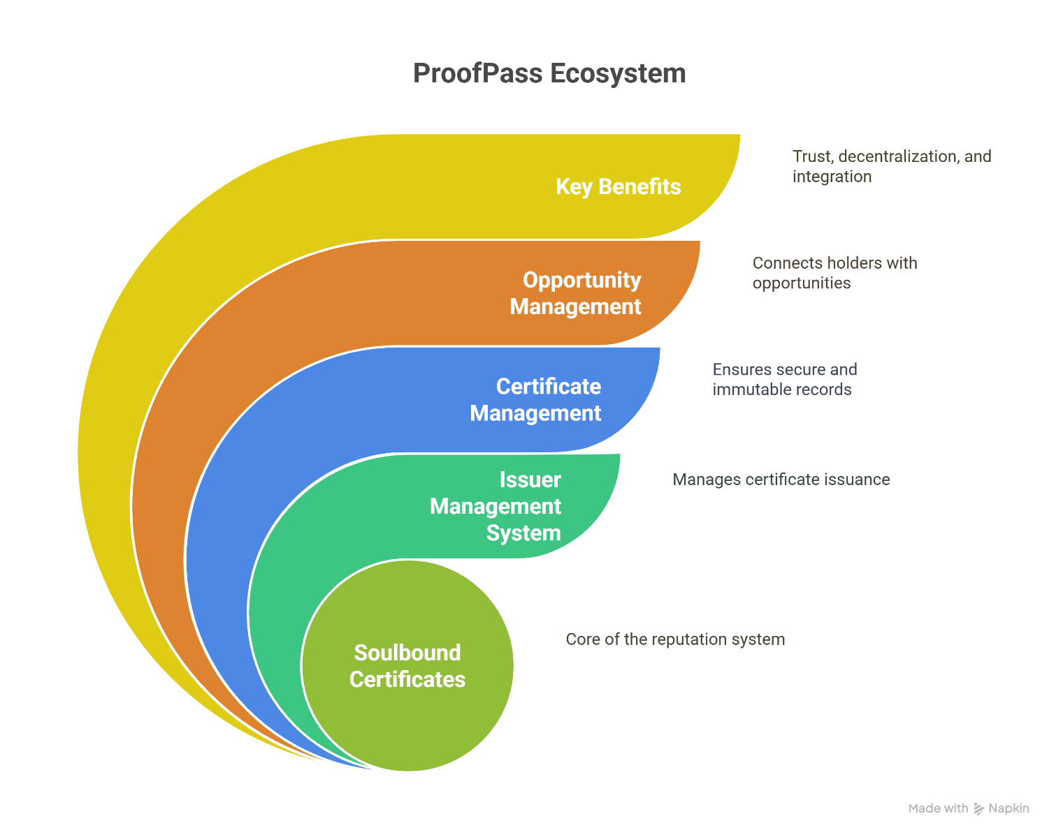

**Target Audience**

1. **Certificate Issuers**

* Educational institutions
* Professional certification bodies
* Project maintainers and organizations
* Community leaders

1. **Certificate Holders**

* Developers and technical professionals
* Students and learners
* Community contributors
* Job seekers

1. **Opportunity Providers**

* Companies seeking verified talent
* Project maintainers looking for contributors
* Organizations offering opportunities to certified individuals

**Key Benefits**

1. **Trust and Verification**

* Immutable proof of achievements and credentials
* Transparent issuer verification system
* Permanent record of professional history

1. **Decentralization**

* No central authority controlling certificates
* Transparent and auditable issuance process
* Censorship-resistant credential system

1. **Integration**

* GitHub integration for developer verification
* Opportunity marketplace for certified individuals
* Extensible system for various types of certifications

**Technical Implementation Details**

1. **Smart Contract Architecture**

* ERC721-based soulbound tokens
* Role-based access control for issuers
* Comprehensive event logging system
* IPFS (Pinata) integration for metadata storage

1. **Frontend Architecture**

* Modern, responsive UI using Chakra UI and Tailwind CSS
* Web3 integration for blockchain interactions
* Role-based access control in the frontend
* Comprehensive dashboard for different user roles

1. **Security Features**

* OpenZeppelin contracts for secure implementations
* Role-based access control
* Immutable certificate records
* Transparent activity logging

**Future Potential**

The platform can be extended to support:

* Additional verification methods beyond GitHub
* Integration with other blockchain networks
* Advanced reputation scoring systems
* Automated verification processes
* Enhanced opportunity matching algorithms

This project represents a significant step forward in creating a decentralized, trustless system for professional reputation and certification, leveraging blockchain technology to provide immutable and verifiable credentials in the digital age.  
  
